CONTENTS
ACKNOWLEDGEMENTS
A MESSAGE FROM THE BOARD CHAIR, BEVERLEY KLIGER
A MESSAGE FROM THE CEO, JULIE KUN
STRATEGY AND VISION
THE WIRE MODEL
INTERSECTIONALITY ACTION PLAN
SUPPORT delivered by WIRE 2020-2021
What an incredible journey we
have travelled together this year
WIRE SERVICE DELIVERY CONSULTATION
VOLUNTEERS AND SUPPORT WORKER TRAINING
FOUNDATIONS AND IMPACT
PROJECTS AND RESOURCES
THE PURSE PROJECT 3
CREATING A FINANCIAL WELLBEING
THEORY OF CHANGE
COVID-19 FINANCIAL CAPABILITY
AND INTERSECTIONALITY PROJECT
SKILLED AWARE RESOURCEFUL ACTIVE (SARA):
FINANCIAL WELLBEING TRAINING FOR WOMEN
SUSTAINABLE AND TRANSFORMATIVE
EMPLOYMENT PATHWAYS (STEP) PROJECT
RESPECTFUL RELATIONSHIPS & MONEY - CONVERSATIONS KIT
THE WOMEN’S FINANCIAL CAPABILITIES PROJECT (WFCP)
THE SOCIAL INCLUSION PROJECT
PROFESSIONAL TRAINING AND CONSULTATION
ADVOCACY
LOOKING FORWARD
OUR BOARD
FUNDERS, PARTNERS AND SUPPORTERS
FINANCIALS

Acknowledgements
WIRE acknowledges that Aboriginal and Torres Strait Islander
peoples are the traditional – and only – custodians of country
across Australia. Aboriginal and Torres Strait Islander peoples
continue to maintain their wisdom and rich culture—the oldest
continuous culture on the planet—despite having experienced
genocide, dispossession and colonisation. We recognise their
continued connection to land, waters and culture, and pay
our respects to their Elders, past and present. Sovereignty
has never been ceded. This land always was and always
will be Aboriginal land.

Women’s Information and Referral Exchange Inc
ABN 98 957 157 895
Victorian Associations Incorporated Registration A10000122S
Victorian Registered Fundraising License FR0012196

MESSAGE FROM THE CHAIR
Beverley Kliger
The annual report sets out WIRE’s research,
project and advocacy outcomes that support and build a stronger, healthier community, aligning with WIRE’s unique strength-based model. During this time of change and uncertainty, WIRE has continued to grow, improve and build connections to the community. Aptly, community is the theme of this year’s annual report to celebrate the courage of our Victorian community members as they find ways to continue supporting each other through the pandemic when structural systems fail.
We, the Board members of WIRE, are very proud of the way in which the resourceful staff have continued to support the community through the continuing stress, pressure and disruption to daily lives stemming from the continuing COVID pandemic. In 2020-21, WIRE adapted to a COVID world by redesigning the phone room to ensure staff and volunteers can effectively and safely support service users. WIRE also expanded its management team and, through its training and education capability, continues to increase its engagement with a range of sectors that cultivate respectful conversations with all people in the community and workplaces.

WIRE welcomes all women, non-binary and gender diverse people in Victoria. At our last Annual General Meeting in 2020, WIRE aligned its constitution with its Trans and Gender Diverse Inclusion Policy that has been followed for the last 5 years. To ensure that WIRE appropriately and sensitively works with Victoria’s multifaceted community, we aim to enhance the way we work and focus on addressing the systems and structures that lead to oppression, marginalisation and disadvantage. To achieve this, WIRE is developing a comprehensive Intersectionality Action Plan to ensure we implement intersectional feminist practices across the organisation.
WIRE is recognised for its expertise with regard to gender and financial capabilities, particularly how to recognise and assist women experiencing financial abuse. WIRE’s Purse Project in 2020 was designed for community service professionals to deepen their knowledge and gain new skills that can help women to recognise financial abuse, build their financial skills and capacity, and improve their financial outcomes. The successful project was awarded
the Gender-wise Philanthropy Award for 2020.
I would like to take the opportunity to thank and acknowledge the dedication and resilience of Julie Kun,
our CEO, and all the staff and volunteers for maintaining quality services and support to the community in these times of constant uncertainty and change. I also sincerely thank and acknowledge the immense work that has been carried out by the Board of passionate and talented people for calmly leading, despite the challenges of the year.
I would also like to thank and recognise the work of the fabulous Board members who retired after many years of dedicated work with WIRE. Thank you—you have
contributed to WIRE’s ongoing evolution.
Finally, we are very grateful to WIRE’s many supporters, partners and peers for standing with WIRE in our work to redress oppression and marginalisation experienced by women, non-binary and gender diverse people.

A MESSAGE FROM THE CEO
Julie Kun
WIRE has experienced a year like no other, one in which the value of community has been felt more keenly than ever before. In regards to WIRE’s staff and volunteers, including the Board, I have been in awe at the levels of support and fellowship that we have shown each other as WIRE continually adapts to rapidly changing conditions, including locking down and reopening our office based on COVID restrictions. But it’s not just the emotional support that is clearly evident, it’s the intellectual support and the determination to solve problems we have never encountered before. For example, managing density limits in an office of staff, providing high quality service provision and maintaining our reach by providing online training and community outreach.
Now more than ever, our Victorian community needs support and innovation. That’s why at WIRE, we’ve moved our service delivery phone room to a larger space, so that it can remain open during the harshest of lockdowns. We’ve also created an online room, so that staff have a dedicated space to deliver high quality online information and community outreach sessions and training. But it hasn’t been easy: as I write this, it’s been weeks since I’ve been in the office, as working from home allows frontline staff to take up the office density quota and prioritise supporting the community as much as possible. I miss seeing staff and volunteers, and being among the general hum of the office. But in team meetings and regular catch ups, WIRE has enabled that sense of community and connection to continue—and for that I am ever grateful.
WIRE exists to support and lift up Victorian women, non-binary and gender diverse people, and we acknowledge that every WIRE volunteer, staff member and Board member also makes up a part of this community. We see the resilience and strength of our service users and their diverse communities in our direct service delivery work, project work, training
and advocacy. In particular, we see the resistance of communities experiencing the ongoing impact of sexism, racism, ableism, transphobia and other formsof discrimination that are never acceptable, but sadly all too common.
Every day we hear stories of community and hope: service users tell us how they’re supporting friends, family members and colleagues and ask us what they can do to assist those they care about; they continue to strive for safety, security and wellbeing for themselves and their families. WIRE provides support to thousands in the community each year, and it’s an honour to be part of the community in such a meaningful way.
I want to thank every volunteer and staff member for not only continuing to be part of the WIRE community, but for participating in such an active and thoughtful way. Thank you for bringing your skills, knowledge and dedication to WIRE every day—you are amazing. I also want to thank all of our pro bono professional volunteers that have enabled WIRE to provide support to job seekers; legal information to people needing property settlement (as part of the separation and divorce process); and key financial information to our community.
Thank you to WIRE’s Board Chair Beverley Kliger and the whole WIRE Board for your unwavering dedication to the WIRE community. Thank you to our funders for your support and for being with us in every pivot of the COVID journey. To everyone that refers people to WIRE, we are honored to have your confidence—thank you. And last, but certainly not least, thank you to the thousands of service users in our community that access WIRE by phone, email and web chat, and sometimes even at the office—we are only here because of you. You give us hope and we learn so much from your courage to survive and thrive.

STRATEGY & VISION
WIRE’s strategic direction 2019 – 21
Built on feminist, inclusive values, WIRE’s vision is of a just and inclusive society where all people can thrive. We work with women, non-binary and gender diverse people in Victoria to address the issues they identify, assist them to make informed choices in their lives, and advocate for structural change to bring about gender equity and social justice.
Over the last few years, WIRE has grown in size and expanded its focus, becoming an influencer and advocate on key issues impacting our community. This has led to an increased focus on researching, designing and delivering evidence-based Programs to address issues of economic and financial inequity, while continuing to provide support, referral and information services to people who seek our services.
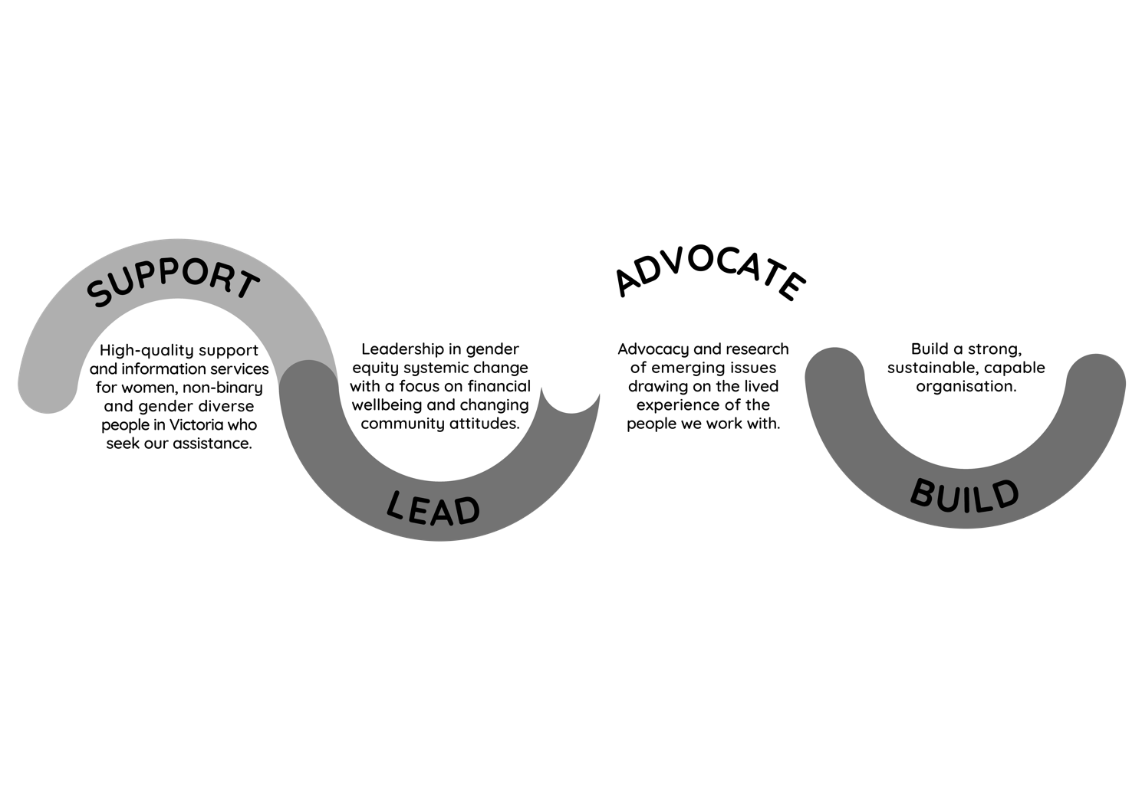
In 2019, WIRE committed to a strategic plan to maximise its social impact and consolidate the progress made in tackling issues facing women, non-binary and gender diverse people in the Victorian community. We listened to the lived experiences of our community to ensure our services meet their needs, and that our research, advocacy and programs make a positive difference for gender equity and social justice across the community.

Our key strategic pillars are to:

Over the last three years, we worked to collectively accomplish these goals and determined our success by:
- empowering Victorian women, non-binary and gender diverse people to feel informed about their rights; confident in making financial decisions; and a greater sense of control in their lives;
- amplifying the lived experiences of women and non-binary and gender diverse people to influence policies and make services and practices more responsive to the communities WIRE assists;
- raising awareness about the causes and impacts of gender discrimination and financial abuse and influencing systemic change;
- becoming a leading reference point for government and other key stakeholders on gender equity and financial wellbeing issues;
- building a diverse range of sustainable and evidence-informed programs that create meaningful and measurable change to individuals, communities and social structures;
- challenging existing systems and structures to ensure that services are accessible, inclusive, non-discriminatory and responsive to diverse groups; and
- building long-term, positive and productive relationships with partners, members and donors.

Looking forward: Strategic plan 2022-2025
WIRE continues to strive for social justice, equity, fairness and integrity, and we are currently in the process of forming a new strategic plan for 2022-2025.
We’re conducting a high-level review of the 2019-2021 strategic plan with plans to evolve and expand our goals
as our team, research, programs and service offerings continue to grow. As part of this review, we’re seeking input from people who use our services (and prospective service users), people who refer to our services, funders and project partners, our volunteers, staff and Board. We will look at the impact of COVID and other political, economic, social, technological, legal and environmental conditions faced by women, non-binary and gender diverse people in our Victorian community.

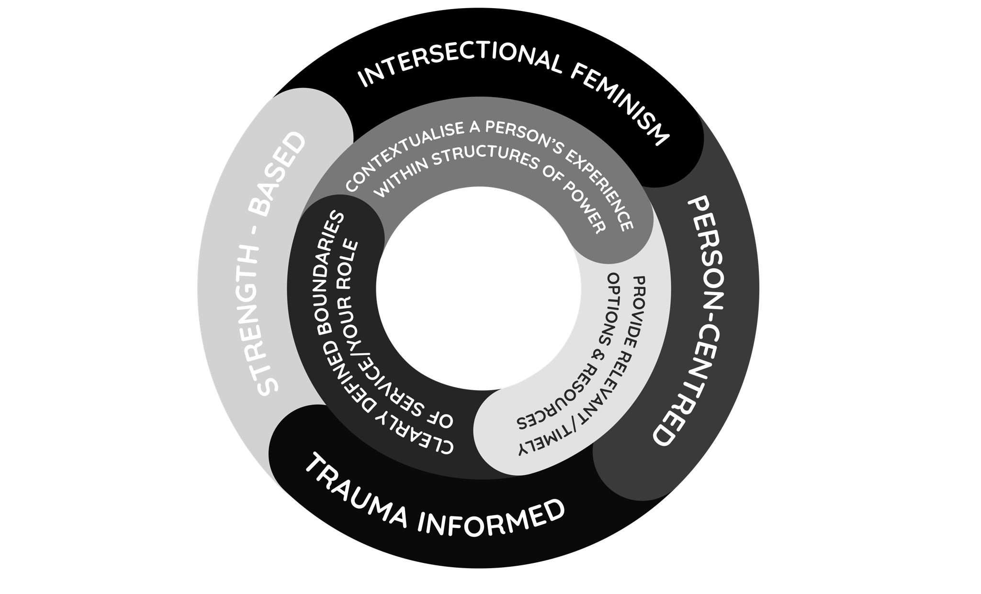
THE WIRE MODEL

WIRE’s unique gender-informed, strength-based model of service delivery, research and training is based on decades of practice and evidence. The model supports the empowerment
of women, non-binary and gender diverse people by:
- listening to and believing their stories and validating their existing strengths, values and priorities;
- providing a safe place to explore options, exchange information and provide support and referrals to meet their needs; and
- locating an individual’s experience within broader structures and exploring how they can exercise agency within those structures.

“Intersectionality is a way of seeing or analysing the dynamics
of power and social inequality in our society…[it] is the recognition
that inequalities are never the result of any single or distinct
factor such as race, class or gender. Rather, they are the outcome
of different social locations, power relations and experiences.”
Olena Hankivsky (2014, Canada, Policy).

The core elements of the WIRE model:
- are based on feminist, trauma-informed principles;
- value agency, acknowledging that the person experiencing the issue has invaluable expertise and knowledge about their situation;
- use a rights-based approach;
- recognise the systemic and structural barriers people face;
- are intersectional: recognising that people experience different levels of oppression or privilege depending on where they are located in society; and
- recognise the power asymmetry between services and service users.

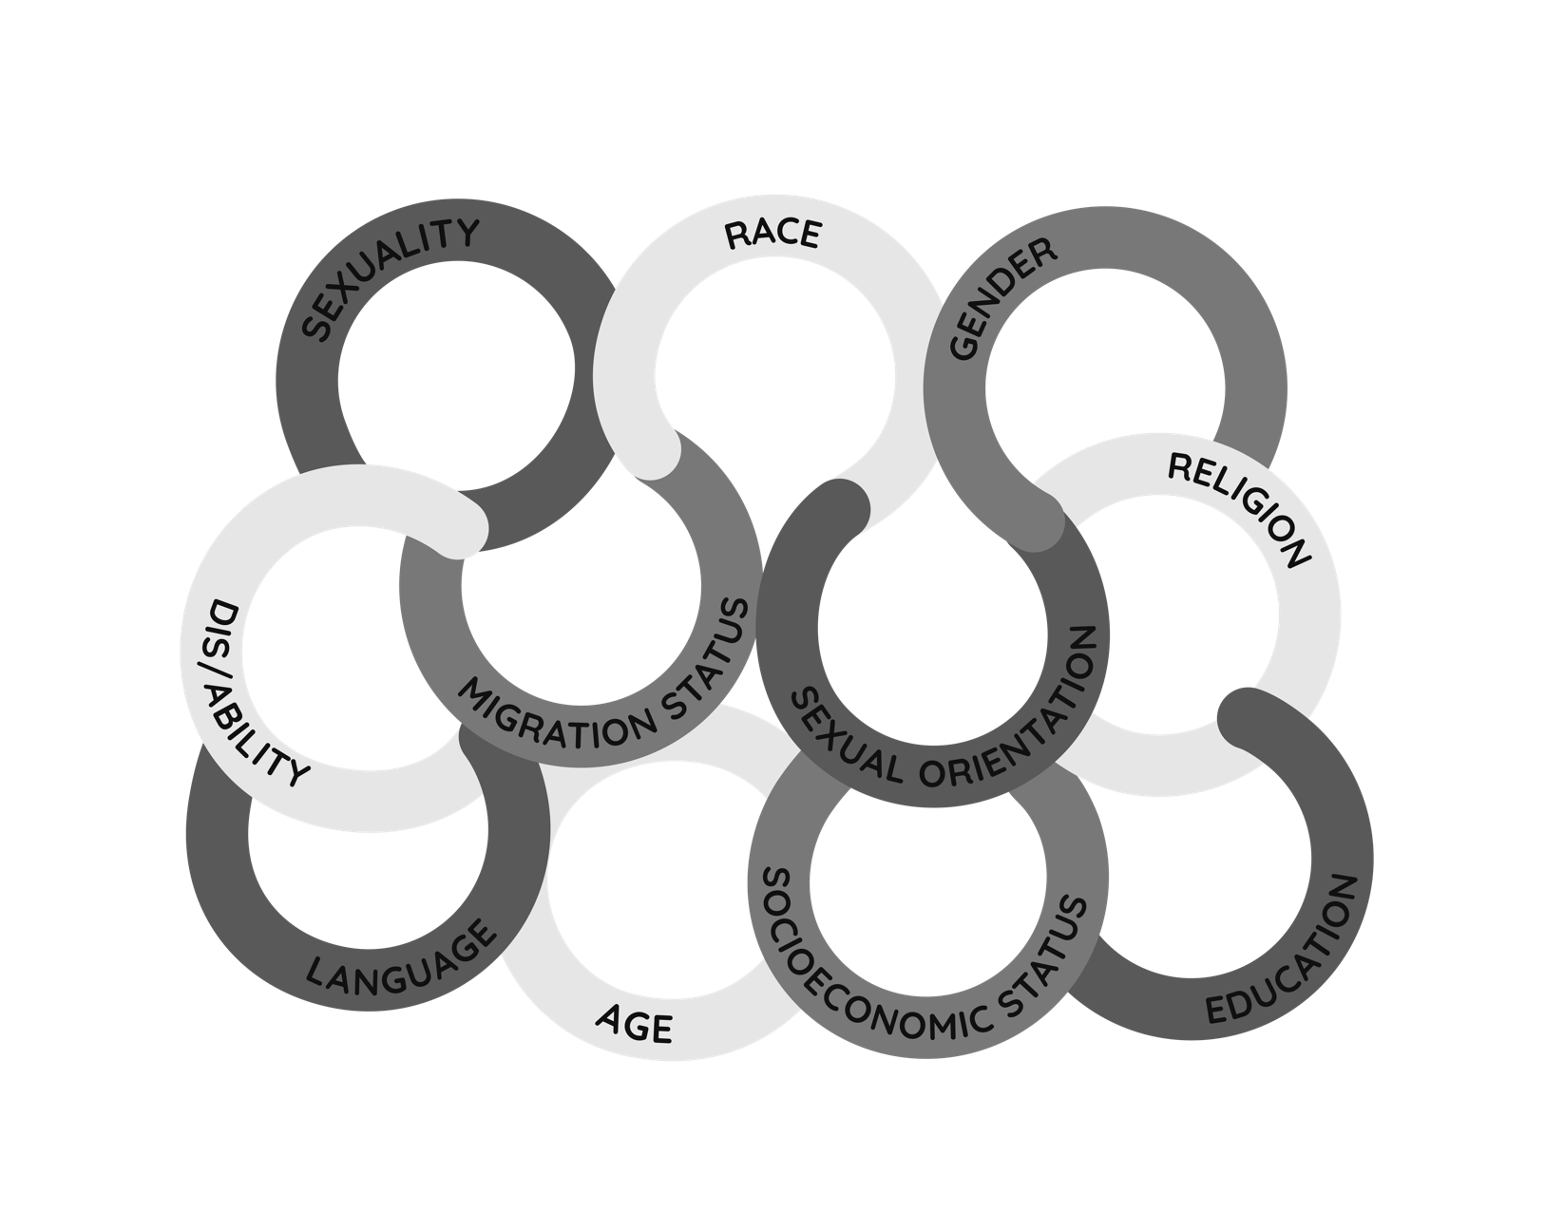
AN INTERSECTIONAL LENS

As part of the WIRE model, applying an intersectional lens helps us to understand how the power dynamics and social and economic systems in our society operate to privilege some people and oppress and marginalise others. People who are oppressed and marginalised by our systems experience barriers to safety, justice and resources they need—they have less opportunities to thrive. In our community, marginalised groups experience different forms of discrimination, such as racism, classism and sexism, because of our society’s power structures and systems of inequality and injustice.
The overlapping social factors and locations of people—such as race, gender, migration status, or varied abilities—only become a source of compounded disadvantage and marginalisation when our society’s systems construct and reinforce them.
Everyone has their own unique experiences of discrimination and oppression and we must consider all the ways that
our society’s systems perpetuate these experiences. For example, a woman of colour may experience sexism and racism, but she will experience sexism differently from a white woman and racism differently from a man of colour.
To support women, non-binary and gender diverse people, the WIRE model must be intersectional—because any feminism that only represents the experiences of white, middle class, able-bodied, heterosexual people will fail to achieve equity for all in our community. At WIRE, we strive for an inclusive, feminist practice. This means listening to and amplifying the lived experiences of all Victorian women, non-binary and gender diverse people, and centring the voices of those who experience the most disadvantage.

INTERSECTIONALITY ACTION PLAN
Project Leads: Dr Nilmini Fernando and Manal Shebab
The advent of COVID-19 in 2020 brought into plain sight the devastating impacts of current hierarchical structures on those pushed to the bottom of the social ladder in Australian society. It also heightened awareness of the global struggles for racial justice in the Black Lives Matter movement and the reckoning of the impact on colonisation here and elsewhere.
WIRE has embraced this opportune moment to strengthen WIRE’s incremental journey towards purposeful and intentional intersectional feminism. This work is urgent if we are to build back better in a COVID world and serve the needs of our community.
The WIRE Board, staff and volunteers express a strong commitment to build effective intersectional practice that is inclusive and caters to the shifting issues for our service users. WIRE’s dedicated, talented team is committed to integrating intersectional feminist practice across WIRE policies, programs, governance and service. This commitment is based on the positive impact it can have on service users, the community, staff and volunteers.

“WIRE is on a journey of transformation and needs to do this to reflect the feminist values of a changing society.”
(Quote from staff survey)

WHAT IS INTERSECTIONALITY?
Professor Kimberlé Crenshaw, a pioneering scholar and writer on civil rights, critical race theory and Black feminist legal theory, says:
“Intersectionality is a metaphor for understanding the ways how multiple forms of discrimination and disadvantages sometimes compound themselves, and they create obstacles that often are not understood within conventional ways of thinking about anti-racism, or feminism, or whatever social justice structures we have.”

Why an Intersectionality Action Plan (IAP)?
The community service delivery system in Australia has traditionally viewed people and provided services around a single attribute or issue, e.g. gender identity, sexual orientation, migration status, etc.
“There is no such thing as a single-issue struggle, because we do not live single issue lives.”
- Audre Lorde, American writer and activist.
Our service delivery, research and project work continue to uncover the barriers we need to overcome to become a just, equitable and inclusive organisation for all Victorian women, non-binary and gender diverse people.
The purpose of the IAP and its deliberate processes is to build and embed WIRE’s intersectional, feminist values and principles across the whole organisation to improve outcomes for the community, service users, volunteers and staff.
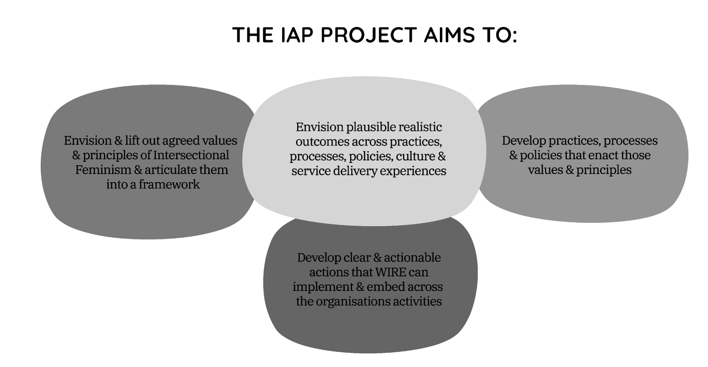
The IAP takes both bottom-up and top-down approaches, inward and outward-facing. It will first articulate WIRE’S shared values, principles and vision of an Intersectional Feminist Framework (IFF) (that aligns with both feminism and intersectionality), then create actionable practices and policies that strengthen activities where intersectionality is done well and further develop areas that can be done better. This will then enhance WIRE’s external approaches to better represent and serve the Victorian community.

WIRE moved from an emerging recognition for expansion of how we understand ‘gender’ and, from 2014, intentionally moved towards adopting intersectionality into training and service delivery with a primary focus on gender diversity.
A more explicit intersectional lens was applied via projects developed from 2017-2019, through WIRE’s Teachable Moments research and Purse Projects 2 and 3, and, in line with increased racial diversity among staff, extended to focus on race – an area often neglected in intersectional practice in the women’s and community sector.
Led by a cohort of queer, Muslim and women of colour staff, the idea of an IAP was developed in recognition that WIRE still has work to do in serving the full diversity of our communities seeking WIRE’s services.
Through Phase 1 of the IAP, WIRE will not only strengthen itself as an integrated organisation, but build the capacity to be a dynamic learning organisation, both inwardly and outwardly facing.

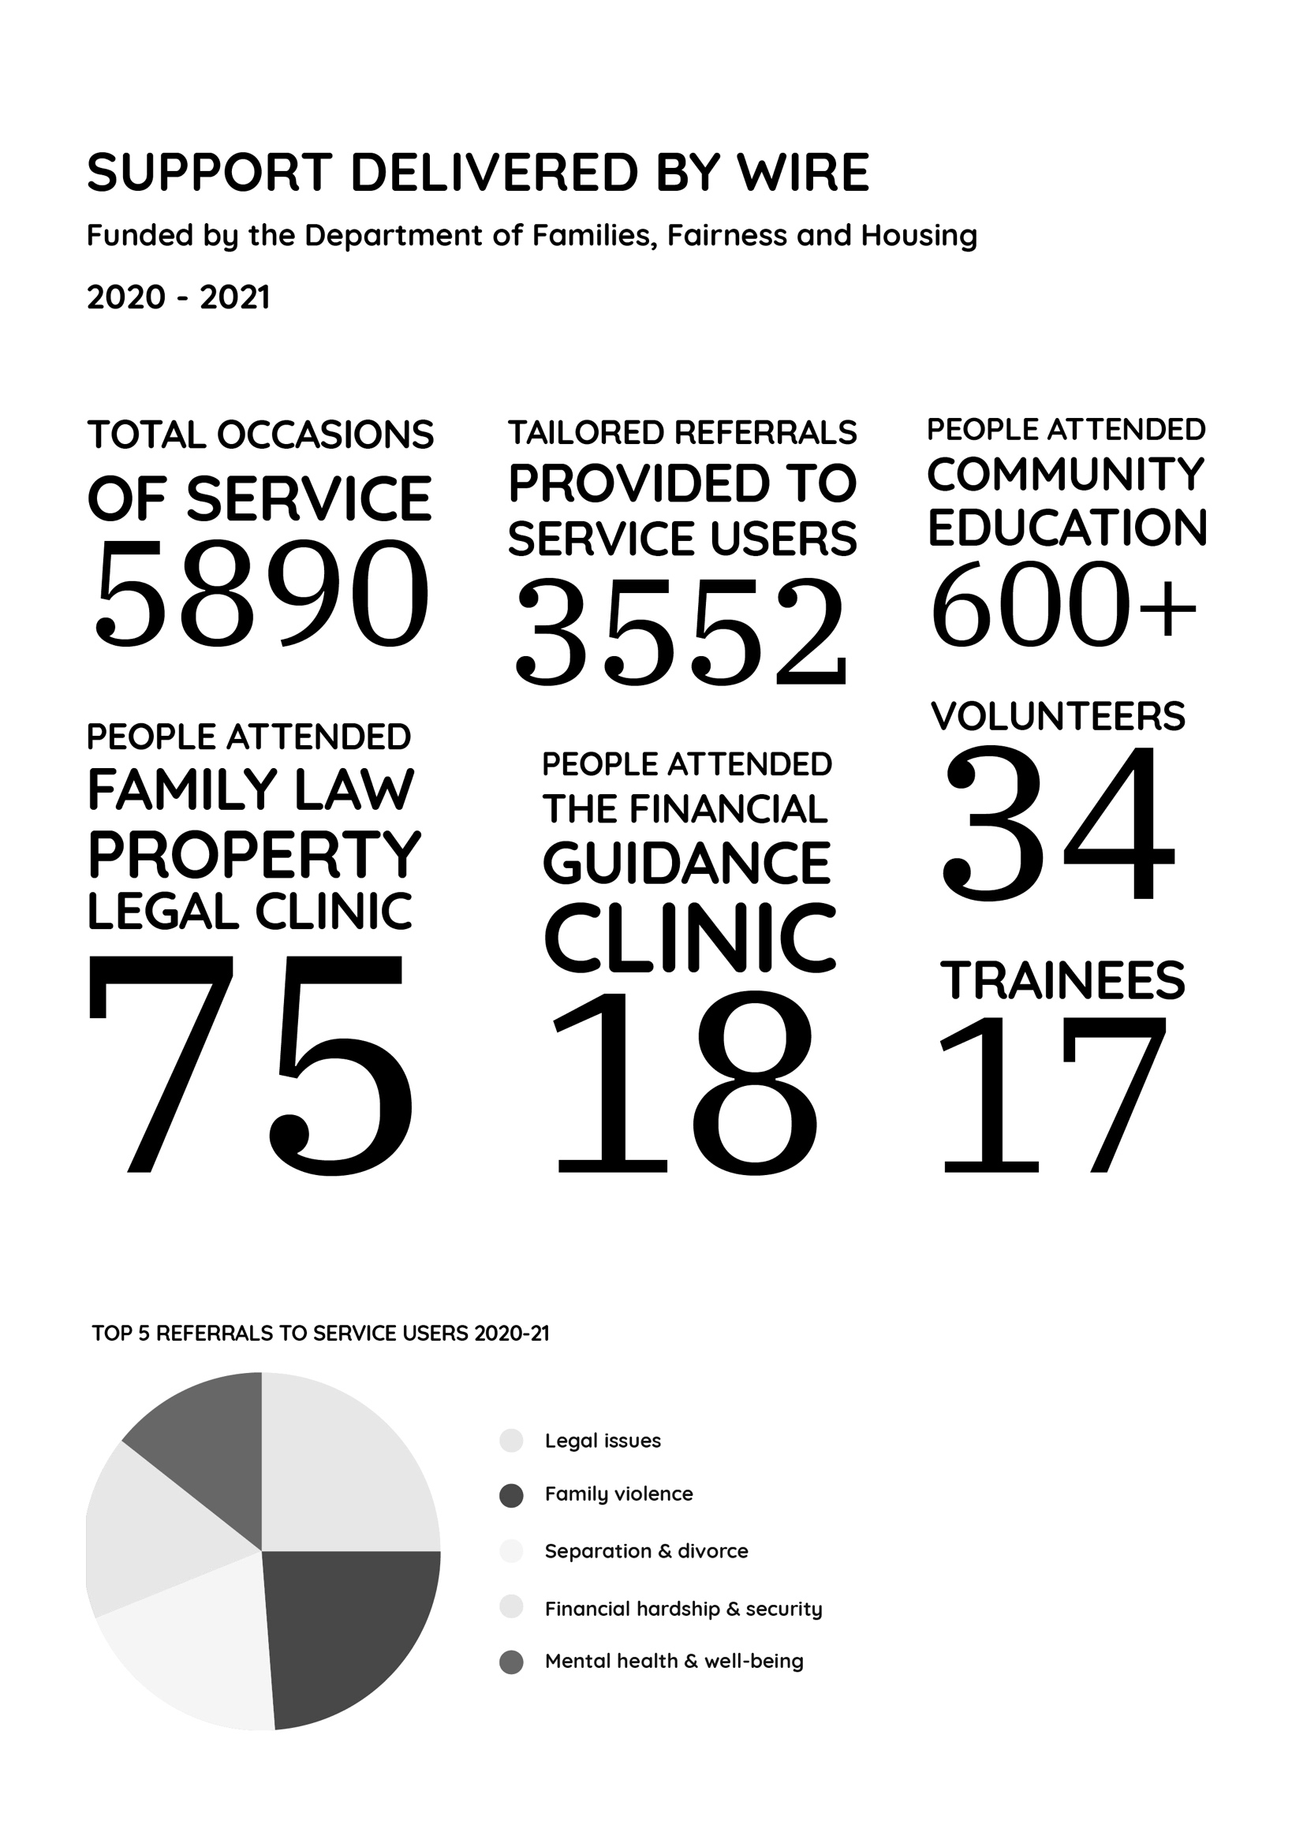

What an incredible journey we have travelled together this year
Service Delivery Manager: Jessica Stott
In July 2020, the WIRE service delivery team was deep in the pandemic providing services remotely from their homes. They worked together in all-day Zoom meetings hearing stories of resilience and courage through adversity from women, non-binary and gender diverse people across Victoria and beyond.
“Our callers are often navigating multiple issues at once—we speak about the fatigue that comes with that. It takes a lot of energy to find housing, employment, overcoming trauma and seeking education. We recognise that it’s a lot work and retelling your story again and again to different services can also be triggering. But with sheer strength and determination they keep calling—usually several organisations at once. They keep persisting and they look for every opportunity to help themselves and their families.”
WIRE Support Worker
Callers shared their experiences of relationship breakdown and family violence, unemployment, insecure housing and financial hardship, frustration with services and disappointment in the government and police, all of which carried common threads of fear, confusion and isolation.
The service delivery team pulled together strongly and provided deep support to each person who calledby listening, believing, validating and exploring their strengths, priorities and options through skilled use of the WIRE model. The resounding response from callers was gratitude, and the team was moved by their courage, creativity, insight and determination.
“Throughout the pandemic, people have lost their jobs and some people, like international students and temporary visa holders, had little to no welfare support or COVID-relief payments. Finding emergency accommodation and housing has always been an issue in Victoria. But now the housing crisis has significantly worsened due to COVID lockdowns and subsequent increased rates
of family violence, pushing out longer wait times for safe accommodation options. And yet our callers are still so resilient and persistent, finding really creative alternatives for accommodation and maximising all the support and resources they have. “
WIRE Support Worker

In December 2020, service delivery started returning to the WIRE office and volunteers started coming back to their work after a period of 9 months. It was a sombre set up with just one person at a time in the phone room connecting remotely with the team through Zoom. What a loss from the days of a bright and bubbly phone room filled with passionate collaboration and conversation! Our heartfelt thanks go out to each and every volunteer who braved this cold and detached environment to be part of this work.
The need for a phone room that was warm, welcoming and spacious—big enough to accommodate a team of staff and volunteers with social distancing—led to the relocation of the phone room to a larger room. The new phone room is now a wonderful plant-filled space and truly the heart of WIRE. Most importantly, it has allowed volunteers and staff to continue working together from WIRE throughout lockdowns to provide a consistent, high- quality telephone support line across Victoria.
“I’m grateful that WIRE is a really supportive space—we all take care of each other, work as a collective and carve out space and time for self and collective care for the sustainability of this practice.”
WIRE Support Worker
In January 2021, the doors of WIRE’s Walk-in-Centre (WIC) opened for the first time in almost a year. This was done with much care and consideration for the safety of the community. Regular service users were welcomed back to the WIC space, albeit through masks and Perspex screens. The WIC services were limited but appreciated by those who used them.
The constraints on face-to-face services became very clear with the continued lockdowns and led us to think deeply about what our communities really want and how WIRE can deliver to them. As a result, we conducted a Service Delivery Consultation with WIRE stakeholders, centring voices of current and prospective service users to create a set of non-negotiable intersectional, feminist principles and a plan to expand our model of service delivery. We had the privilege of working with consultant Navanita Bhattacharya on this project. An excerpt from
her report is included below.
Though the doors of the WIC space have more often been closed than open in the last year, WIRE’s service delivery has risen to the challenge of developing and delivering services that are responsive to community interests, resilient to lockdowns and targeted to the groups that we aim to serve.
Our renewed focus on providing online services and extending our reach (to people who were not otherwise
able to access WIRE) has created many new opportunities for service users to access WIRE. It has also invigorated our commitment to centre the experiences of WIRE service users; to create change through networking, partnering, information sharing and advocacy; and to bring the broader work of WIRE together more strongly than ever.
“… I am continually learning from my experiences here, both through talking with callers, listening to my co-workers and working as part of a team to support people who so often show such resilience and strength in the face of what can seem like overwhelming challenges, traumas and struggles.”
WIRE Volunteer
Our renewed focus on providing online services and extending our reach (to people who were not otherwise able to access WIRE) has created many new opportunities for service users to access WIRE. It has also invigorated our commitment to centre the experiences of WIRE service users; to create change through networking, partnering, information sharing and advocacy; and to bring the broader work of WIRE together more strongly than ever.
In a changing world, the need for support, information, advocacy and connection remains the same, as does WIRE’s commitment to empowering and creating change for the people it serves.

WIRE SERVICE DELIVERY CONSULTATION
Excerpt from WIRE Intersectional Feminist Service Delivery: Review, co-create, adopt by Navanita Bhattacharya
WIRE—especially its leaders and the servicedelivery team—paused to be reflexive, brave, and vulnerable to being critiqued.
The consultation also included the voices of service users and potential service users who courageously shared their stories, expertise and ideas. Through facilitated conversations, participants articulated that they want WIRE to be an organisation with a clear purpose and mission (and an explanation of how this is achieved), and a place where staff and service users can share their stories in ways that resonate with everyone they’re meant to reach and serve, without any ambiguity.
This project provided the scope to critically review the service delivery work of WIRE and collectively envision a more accessible, inclusive and intersectional way of providing services to Victorian women, non-binary and gender diverse people.
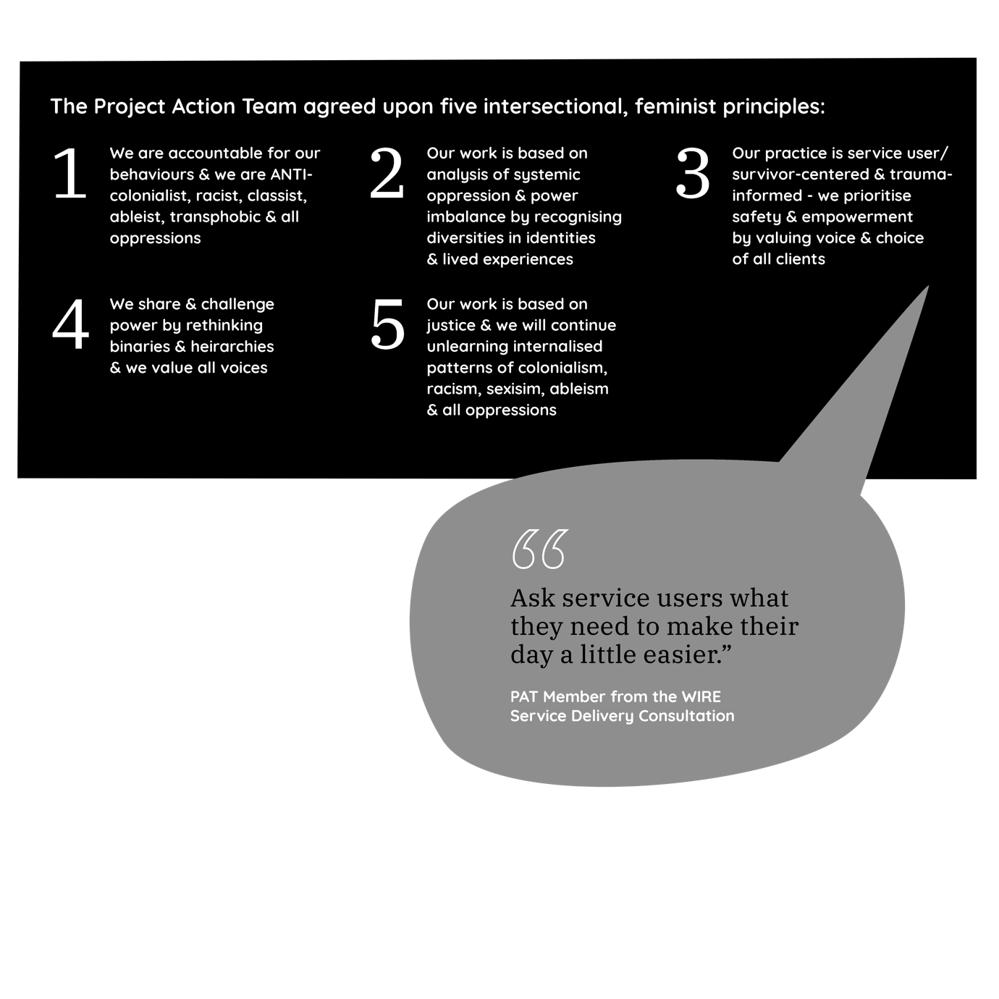
A Project Action Team (PAT)—consisting of 17 members representing WIRE, its Board, its communities, service users and partners/referral agencies—was formed after a call out on social media. The primary purpose of the PAT was to act as an advisory group; review WIRE’s current service delivery model; agree on intersectional, feminist principles and non-negotiables; and co-create a new service delivery model. The valuable outcomes from the service delivery consultation are being used to design WIRE services and programs to be delivered in 2022.

VOLUNTEERS & SUPPORT WORKER TRAINING
Volunteer Training & Education
Coordinator: Vanessa Stathopoulos
Co-facilitator: Alice McDonald

After suspending volunteer training due to the pandemic, WIRE was inundated with applications for the 2021 Volunteer Training. We are privileged to have gone through this journey with a brilliant group of people who stuck by us and the course during a tumultuous year.
I wanted to be part of this powerhouse of an organisation [WIRE] that makes a vital impact on the lives and communities of women,non-binary and gender diverse people. I have my own lived experiences and through them I can bring forward my own compassion, empathy, knowledge and skills to the safe space of volunteering (that WIRE facilitates).”
2021 Volunteer Trainee

With 17 trainees on board, the 2021 course was WIRE’s first training since the cancellation of the February 2020 training due to COVID-19—some parts of the training were moved online due to ongoing lockdown restrictions. We have currently completed 6 weeks of the course (out of the total 8 weeks), with a plan to finish the course and continue training and practice in the phone room, once restrictions allow.
I appreciated the perspectives of the WIRE training coordinators, how they worked together as a team and how they injected humour, lightness and authenticity throughout each session to make the training enjoyable.”
2021 Volunteer Trainee

The course featured topical presentations by expert guest speakers from a variety of organisations including Harm Reduction Victoria, VIXEN Collective, Safe Steps, Eastern Community Legal, Housing for the Aged Action Group, Council to Homeless Persons and Women’s Legal Service. Individual guest speakers included Vincent Silk and Alice McDonald , Monique Hameed and Maya.
I learn more and more each day about how women, non-binary and gender diverse people are resilient and courageous in their mission to stay safe, protect their loved ones and to be brave by reaching out to talk to a stranger at WIRE.”
2021 Volunteer Trainee

WIRE wouldn’t exist without our volunteers

WIRE thanks everyone who applied to be a part of WIRE’s 2021 Volunteer Support Worker Training. To the 2021 training cohort – thank you! We have thoroughly enjoyed the time we have had together. It has been a pleasure to get to know you all and we mean it when we say that the best part of our job is working with you.
Thank you to Julie Harper who holds so much WIRE wisdom. And a big thanks to our expert guest speakers for their invaluable contributions to the training and to our ongoing learning.
We are committed to providing quality training and support for incoming volunteers, and we look forward to welcoming you in our future courses. See you in 2022!

I’m deeply touched and humbled by the communities and members that seek WIRE as a support, as I believe they each have tremendous strengths and gifts to share with their communities.”
2021 Volunteer Trainee

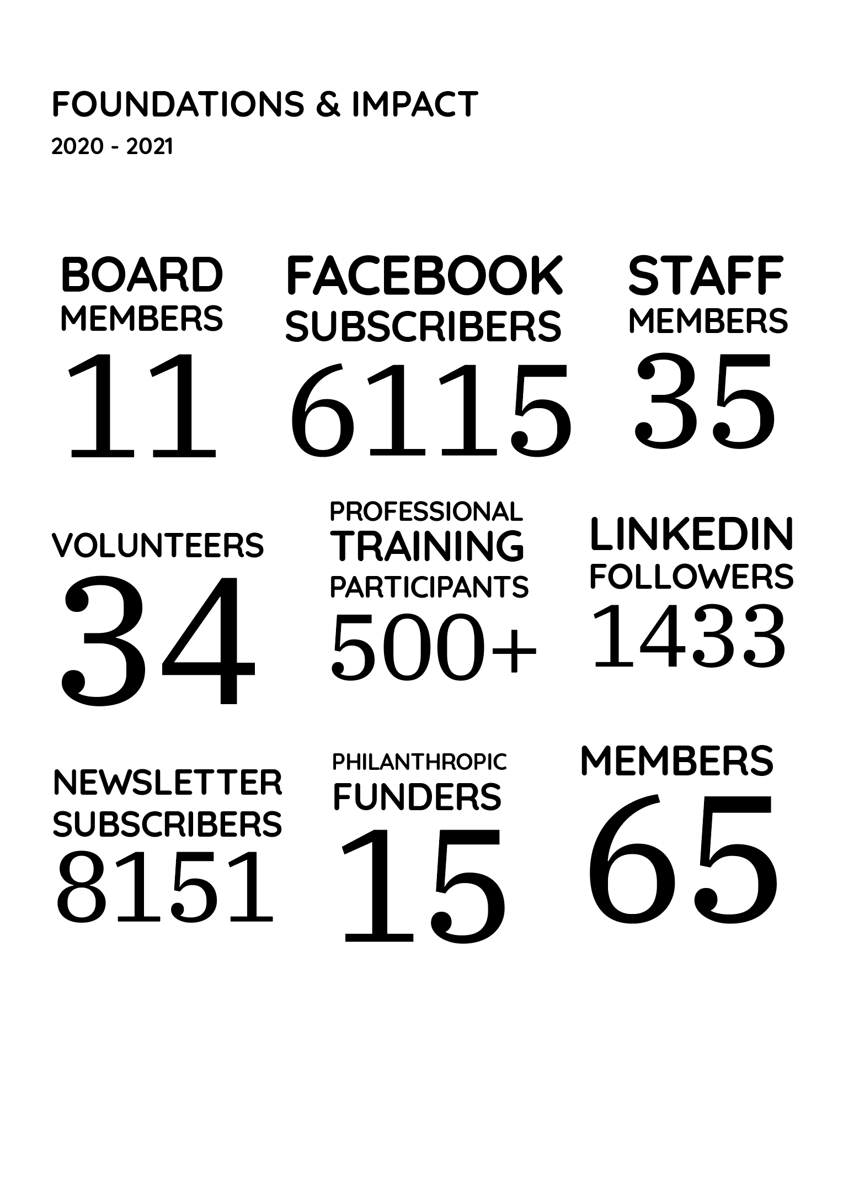

PROJECTS & RESOURCES
THE PURSE PROJECT 3
Project Coordinator/Educator: Dr Nilmini Fernando
Co-Facilitators: Julie Harper and Manal Shebab
The Purse Project, which won the Gender-wise Philanthropy Award last financial year, has evolved across three iterations. Funded by the McNamee Foundation, it was initiated in 2016 to focus on the financial wellbeing of victim-survivors of family violence and professionals who serve them. Building on the success of Purse Projects 1 and 2, Purse Project 3 (2019-2020) adapted and delivered half-day training workshops for community services professionals from 20 community sectors and over 35 organisations.
The training aimed to improve participants’ knowledge, skills and confidence to identify financial abuse. It emphasised the use of targeted resources and timely referrals that can disrupt or mitigate the impacts of financial abuse, as well as techniques to build financial capability and wellbeing for victim-survivors at any phase in their family violence journey.
Due to COVID-19, the Purse Project Training moved online in June 2020 and produced a number of videos and online training materials. The embedded intersectional lens of the project led to the development of a WIRE Financial Capability Practice Framework that is used for other financial capability projects.
The training workshops were co-designed and co-delivered with WIRE staff and were delivered to a total of 435participants. 86% of participants reported that the training increased their knowledge and skills to recognise and respond to financial abuse; 85% of participants reported an increased ability to build financial capability for victim-survivors. Practitioners—at all levels, from beginner to advanced—gained significant lessons.
A specific third aspect of the Purse Project 3 was to provide training workshops aimed to develop and enhance intersectional practice within WIRE, as well as training external organisations. Overall, WIRE staff who participated felt greater confidence to make effective referrals through resources about existing organisations and services to build financial wellbeing.
Participants appreciated the evidence-based knowledge which was applied through a holistic feminist framework. It highlighted the intersection between gender, economic security and family and domestic violence, and contextualised the complexities of women’s relationships with money.

“[What I found most useful was]: Acknowledging and making a connection between the emotions that arise from talking about money. Discussions around gender and finance. Being able to address financial abuse on its own, as well as within the broader framework of family violence. Intersection between gender, economic security and family and domestic violence.”

Intersectionality is an important element of WIRE’s financial capability work, and the Purse Project provided time and space to draw from existing knowledge, apply new knowledge, and shift attitudes and perspectives towards interlocking structures that push particular groups of people in Australian society to the margins. These featured quotes are some comments from WIRE participants that reflect the most significant changes in their practice over time.
“As a result of the training, I am more able to communicate my understanding of an intersectional feminist framework to people using the service. I can use this to highlight oppressions that people are experiencing which are creating barriers to their safety, equity and justice. I can also use it to challenge peoples’ discriminatory attitudes in a way that deepens the conversation and maintains connection and rapport.”
“The intersectional framework has helped me respond to callers when they share their experiences of navigating these systems, and [the training] has increased my ability to use the feminist framework aspect of the WIRE model in a more meaningful and informed way.”

CREATING A FINANCIAL WELLBEING THEORY OF CHANGE
Project Lead: Dr Zuleika Arashiro
Through a range of projects, training and research, WIRE has become a well-known organisation in the financial capability field. Following WIRE’s commitment to an intersectional, feminist approach, all of our projects and research have been informed by the need to amplify the voices of the most marginalised groups in our community, and to ensure that the systemic barriers to their financial wellbeing are recognised.
This work aligns WIRE’s philosophy around financial wellbeing through the development of WIRE’s Financial Wellbeing Theory of Change and a supporting knowledge paper. The ongoing project shows how WIRE’s practice and research is committed to systemic change by integrating actions at the individual, organisational and systemic levels.

COVID-19 FINANCIAL CAPABILITY AND
INTERSECTIONALITY PROJECT
With support from the Ecstra Foundation, WIRE conducted the COVID-19 Financial Capability and Intersectionality Project between September 2020 and March 2021. The project aimed to make visible the discrimination some groups of women, non-binary and gender diverse people faced, and to co-design resources that supported their financial capability on their own terms.
An outcome of this project was the report Too visible, yet not fully seen. The research was prepared with the intention of documenting the main lessons gained from the project implementation. Findings from consultations illustrated why an intersectional lens matters and how marginalisation was reinforced during Australia’s lockdown restrictions—many people were negatively impacted by restrictions, including women, migrants and refugees, temporary visa holders and people with a disability.
As part of the project, a range of resources were co-created for and by community members, including international students, migrants and people with a disability.
As Australia moves into economic recovery, the financial capability sector needs to make visible which groups were more affected, so that those groups can be supported by our services and institutions. This report concluded with a set of 16 recommendations for government and services on how to support people’s financial capability.
Download the Too visible, yet not fully seen report here.
Click here to view and download all community resources from this project.

SKILLED AWARE RESOURCEFUL ACTIVE (SARA):
Financial Wellbeing Training For Women
Project Lead: Julie Harper
WIRE’s Skilled Aware Resourceful Active (SARA): Financial wellbeing training for women was developed and implemented in response to Victoria’s Royal Commission into Family Violence Report. The SARA course primarily focused on the impact of financial abuse in family violence, but also addressed how structural gender inequality and economic insecurity contributes to the poverty of women and their level of financial capability.
My team and I believe that SARA has made huge improvements in the lives of our participants and it’s such a valuable program.”
SARA Trainer
The 10-week course adopted an intersectional, trauma
and gender-informed approach that focussed on participants’ strengths and behavioural change. When we say ‘behavioural change’, we are referring to participants setting and working towards reaching their own sustainable financial goals. In addition to victim-survivors of family violence, the course was also designed for any woman wanting to improve her financial wellbeing by building confidence, knowledge and skills around managing their finances.
In 2021, select Learn Local organisations throughout Victoria ran the SARA course. Despite the lockdown restrictions, many of the organisations have already successfully completed the 10-week training program. Although funding for SARA has ceased, WIRE has received a lot of interest from the community services sector and women’s empowerment organisations. The course was independently evaluated by SmartSteps Financial Literacy who acknowledged that SARA achieved world-class outcomes in financial literacy education. WIRE will continue to lean on the invaluable insights that came from SARA to inform future courses and research. WIRE is continuing to seek funding for this important and innovative program.
I hope we are able to empower many more women to take control of their financial situation and support them on this journey.”
SARA Trainer
SARA was funded by the Victorian Department of Education as a non-accredited financial literacy training program for women affected by family violence.

SUSTAINABLE AND TRANSFORMATIVE
EMPLOYMENT PATHWAYS (STEP) PROJECT
Project Lead: Elyse McInerney
The Sustainable and Transformative Employment Pathways (STEP) Project aims to improve the financial wellbeing of victim-survivors of family violence by improving access to employment.
The program does this in two key ways:
- building job-seeking skills of victim-survivorsand providing them with relevant information to help them find employment; and
- supporting workplaces to implement strategiesthat give victim-survivors more accessible employment opportunities.
The program has helped me think more broadly of whatI’m capable of, what do I needin this moment, and what do I need to help me get to where I want to be next.”
STEP project participant

WIRE piloted the STEP Victim-Survivor Job Seeking program from October 2020 – May 2021. 11 victim-survivors of family violence completed the program, and all have found employment since they began participating in the program.
The STEP project is also developing and trialling a series of workplace standards and guidance materials for employers, so they can implement trauma-informed recruitment processes andbetter support their employees who have experienced family violence.

The diversity [of the STEP program] has been its strength, [participating with] women from other backgrounds and different perspectives. It sends a really nice and powerful message about how women from diverse backgrounds can come together and support each other.”
STEP project participant

Case Study: AMY’S* STORY
Amy joined the STEP pilot program as it was the only program that seemed to really understand the challenge of looking for work after an experience of family violence.
I had been applying for work for a while, with no traction. I knew that the biggest hurdle was that I had gone through a trauma recently, and have been stripped away of all my confidence and autonomy and that needed to be worked on to really put myself out there for work, and be confident enough to sell myself to get the jobs. There weren’t any programs [other than STEP] set
up specifically looking at that.”
Participating in the program not only gave Amy the skills and knowledge she needed to navigate the process of looking for work, it also helped her recognise her own existing skills and value.
The biggest thing [I worked on with my job coach] was really letting me see that I was underselling myself, and that I had a lot of skills but you couldn’t see that in my CV and I wasn’t owning it. We did a lot of work on that…we had a look pragmatically at my skill set, which in turn got me out of that small space I was putting myself into [applying for junior roles].”
As someone who recently migrated to Australia, Amy also really valued the chance to connect socially with other participants, and to work through some ongoing impacts of the trauma she experienced.
I feel like I’ve gained a couple of friends from the program, which is great because I had none before. Even when I [felt socially anxious], I could tell myself no it’s fine, it’s a safe group. It helped me get out of that cycle.”
Amy has recently commenced a management role with a start-up company, however she says the most significant outcome of participating in STEP has been her ability to rebuild her sense of self-worth and her confidence.
I am starting to own my value again. And so, I think it’s probably
the beginnings of building confidence again. I wouldn’t go as far as saying I’m confident, but I’m finally understanding that I’ve been denying the fact that I have certain skills and abilities, and now my traumatic experiences are not defining me as much…I’ve gone from not believing that anyone would hire me to turning down jobs. That’s pretty significant.”
*Name has been changed for privacy reasons.
The STEP Project is a 2.5 year pilot project and is being implemented by WIRE as a proud partner of CommBank Next Chapter, a program designed to make it easier for survivors of financial abuse to start their next chapter and achieve long-term financial independence.
RESPECTFUL RELATIONSHIPS & MONEY
Conversations Kit
Project Lead: Dr Sophia Bilbrough
Over the years, WIRE service users and training attendees identified a real need for resources that demonstrate how to have conversations about money, not only in romantic relationships but with family, friends, children and service providers. People were aware of the inequity and disadvantage that can be the result of not talking about money but didn’t know where to start. Funded by Great Southern Bank, the Respectful Money Conversations project addressed this need. The expectation was that at least one video would be made, with an accompanying booklet. But after the involvement of content advisors—lived experience advocates and selected WIRE staff—it became clear that there were too many urgent topics for a single video, so we made six with tip-sheets
The videos are powerful because they feel so real. We can all learn how to have stressful conversations better and these should be compulsory viewing for anyone working in financial capability or anyone interested in better communication in relationships.”
Presentation attendee
Three of the videos have a Take 1 and Take 2 format, showing two versions of the same conversation: the first take displaying unhelpful behaviours, with a respectful exchange in the second take. The video topics include buying property with family, the economic impact of a pregnancy, and payment of household bills. Financial abuse and coercive control are also shown in one of the relationships depicted in the video.
Best value is Take 2. It’s no good saying to people ‘you should have said it differently or you’re offending people…’ This gives a real example of how.”
Presentation attendee
Made with an intersectional lens, the videos and tool kit bust through stereotypes about gender, age, culture, money and family violence and show women expressing agency. After a launch at the Queen Victoria Women’s Centre in April 2021, the resource has received enthusiastic attention in the sector with presentations on specific videos to Savers Plus (Brotherhood of St Laurence), No to Violence, Partners in Prevention (Domestic Violence Victoria/DVRCV) and Eastern Community Legal Centre.
How many of us who have been abused have also been silenced? Having a voice in this project was monumental for me. For years I’d felt like an amoeba, stuck in trauma and stress and unable to make decisions with clarity. Being part of Respectful Money Conversations was very validating. Important reflections on my own development occurred when I was talking through ideas in a group, and the diversity of experiences was eye-opening. Before this project
I hadn’t thought to have conversations with my friends or children about money, but now I’ve started to. I was also inspired on an artistic level—I’m now writing new songs and taking concrete steps to do new things.”
Mim, Actor and Content Advisor
View the Respectful Money Conversations videos, tip-sheets and booklet here.
THE WOMEN’S FINANCIAL CAPABILITIES PROJECT (WFCP)
Project Lead: Catherine Conolly
The Women’s Financial Capabilities Project (WFCP) aims to improve the financial capabilities
and economic security of women across Victoria, with a particular focus on First Nations women,
women from migrant, refugee, and asylum-seeker backgrounds and women with disabilities.
The project identifies the intersecting barriers faced by women seeking financial security and economic empowerment, and works to find best practice ways to address these barriers on an individual, community and structural level.
The WFCP has developed a five-part project plan as a result of the research, co-design and practice to date.
The holistic plan addresses key barriers to women’s financial capability including a lack of culturally appropriate and accessible information, referrals, services and programs. WFCP incorporates a co-design process that centres the lived experience and expertise of women who have experienced economic marginalisation, supplemented by professional input from cross-sector workers in financial capabilities.
The project is led by WIRE in partnership with Good Shepherd Australia and New Zealand, First Nations Foundation, Brotherhood of St Laurence and Women with Disabilities Victoria, and is funded by the Office for Women, the Victorian Government.
Key project outcomes 2020-21
Money Management Programs: a centralised web resource for finding free, relevant and timely money management programs and events to help our community learn how to make better financial decisions. The web resource is designed to create greater access and ease of referrals to available financial education programs. The webpage gained 1700 unique visits in its first month since launching in May 2021.
Professional Development Suite: In the WFCP, we recognised that workers in financial capability, financial services, community service and referral areas have an unmet need for specialist knowledge and cultural competencies to improve outcomes for women. By training workers in key cultural competencies and the core challenges women experience, we can provide better financial capability to all women in our community accessing those services—from referral pathways to program participation. We have trained over 200 cross-sector professionals in intersectional financial capability and recognising and responding to financial abuse.
Lens On, Hands On: An Intersectional Guide to Financial Capability Program: A practical guide created for people who develop and deliver women’s financial capability and wellbeing programs. The Practice Principles and Tools contained in the Guide outline how to apply intersectionality in their thinking and practice. Seeing through an intersectional lens requires us to understand the experiences of women who face more than one form of unequal treatment and discrimination in their lives. These women are often up against a combination of oppressive systems and power structures, all working together to exclude or keep a person down. The contents of this guide were led by a co-design process with women from these specific communities who, collectively, brought a range of experiences and expertise in financial capability and Intersectionality.
The Women’s Financial Capabilities Project (WFCP) is funded by the Office for Women of the Victorian Government.

THE SOCIAL INCLUSION PROJECT
Project Lead: Anna Andersson
From July 2020 until mid-March 2021, the Social Inclusion Project offered social connection phone calls with the community twice a week. Funded by the Australian Unity and the Count Charitable Foundation, the project engaged with 33 people and provided 276 calls in total during this period. The phone calls provided a safe space for people to share their thoughts, feelings and experiences during the challenging time of the global COVID
19 pandemic and the severe Victorian lockdown. Some people received regular, ongoing calls and others only as needed.
When callers were given the opportunity to express themselves and be heard, they were able to let go
of things and could start to gain new energy to deal with their challenges, overcome barriers or start accessing their inner resources.
Through the social connection phone calls, participants were reminded about their strengths and effective coping strategies and activities they had already used in the past.
Safe and Supported to Blossom research report
An outcome of the Social Inclusion Project was the research report Safe and Supported to Blossom. This pivotal report examined the significance of exclusion and the importance of being part of a community.
Working with community services professionals and people with lived experience, WIRE conducted qualitative research into loneliness and isolation. 32 qualitative in-depth interviews took place: 10 with professionals working in the community services sector and 22 with people who experience loneliness and isolation. Four themes came out of the research: exclusion, systemic issues, community and empowerment.
More than half (64%) of people with lived experience said that they had experienced some form of exclusion that had led them to feel lonely or isolated.
Many spoke of additional barriers and a lack of support from services, demonstrating that systemic issues can either cause feelings of loneliness and isolation or exacerbate these feelings. At the same time, 100% of the people with lived experience stated they wanted to be a part of a community and feel a sense of belonging. Over a third of people with lived experience (36%) stated they wanted to play more of an active role in society and be contributing more in meaningful ways.
This research highlights the human need for connections and it gives evidence that loneliness and isolation is not the fault of individuals, it’s a societal issue caused by social and economic structures.
The research also recommends that any future social inclusion programs take on a more empowering approach that allows for co-design and more active participation, while working on anti-exclusion strategies together with people with lived experience.

Read the Safe and Supported to Blossom report here.

PROFESSIONAL TRAINING & CONSULTATION
Training and Social Enterprise Manager: Mia McDonald
WIRE is renowned for its professional development training, seminars, researchers, subject experts
and advocacy. Our professional training is a product of WIRE’s collective expertise, extensive research and practical experience in understanding and supporting women, non-binary and gender diverse people. We bring together the theoretical and the practical, so participants can use what they’ve learnt in the real world.
In March 2021, WIRE engaged a Training and Social Enterprise Manager to formalise and grow our external professional training and consultation services. To support our growing team and offerings, a comprehensive training manual was created to conduct these sessions.
WIRE also recently developed and updated the WIRE training suite to include our ‘Dealing with Difficult Calls’ interactive workshop, our ‘Understanding and Responding to Family Violence’ training and our new course ‘Recognising & Responding to Financial Abuse’. All of our training courses are available as regular public events and can also be tailored to organisational training needs. In addition, a new evaluation model was designed to collect more responsive feedback from each training session. This model will accurately measure the impact of the training and ensure that it creates lasting impacts in our community.
DEALING WITH DIFFICULT CALLS
This popular workshop is for people who want to develop the skills and knowledge needed to manage difficult or challenging phone calls. This includes responding to callers who present as angry or distressed; have difficulty communicating; or are in a crisis situation. The training is especially useful for phone-based workers including phone intake and response, reception and call centre staff who are the first point of contact for service users and customers across all external facing industries.
UNDERSTANDING AND RESPONDING TO FAMILY VIOLENCE
This full day training provides the skills and knowledge to understand, recognise and respond to family violence. Upon completion, participants are well-equipped to support and provide referrals to anyone—including family, friends, colleagues or staff—who may be experiencing family violence. This professional training is essential for frontline workers, managers and business leaders in all industry sectors.
RECOGNISING & RESPONDING TO FINANCIAL ABUSE
Leveraging WIRE’s expertise in financial abuse, this new training course provides participants with a deep understanding in recognising and responding to financial abuse. By defining and raising awareness of financial abuse, participants learn how to contribute to the economic safety of victim-survivors who have experienced financial abuse. This training is for professionals including people from local authorities, financial institutes, money or debt advice services, the insurance industry, the real estate and housing sector, customer support and the community services sector.
ACHIEVEMENTS
During the period of January to June 2021, the WIRE team has delivered over 72 hours of training: 24 training sessions in Dealing with Difficult Calls and 5 sessions in Understanding and Responding to Family Violence training. Over 500 people participated in training sessions over the 2020-21 financial year, including trained workers from wide-ranging industries, such as health, medical, financial, utilities and community services.
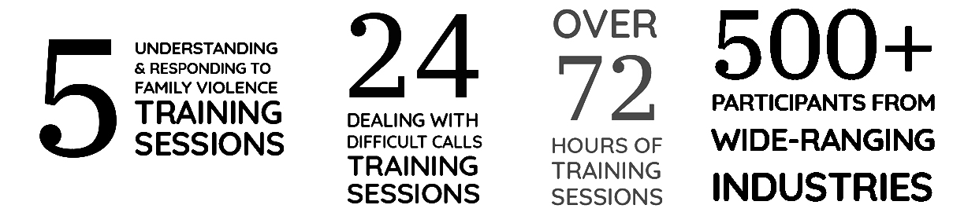

Through our professional development training, we effectively share and embed skills and knowledge across corporate, government and community services sectors to create meaningful and lasting change.
Some of our recent training involved working with insurance companies, financial institutions, telecommunication providers, Essential Services Authorities and community services organisations. This work spans a range of initiatives including policy reviews; tailored in-house training and support; coaching and mentoring; providing expertise to inform content for eLearning packages; and collaborations to contextualise training for large groups of staff.
GENDER EQUALITY ACT PANEL OF PROVIDERS
In 2020, WIRE was selected to be on a panel of providers to work with government-defined entities and assist them to meet their obligations under the Gender Equality Act, which came into effect 31 March 2021. WIRE was one of 24 organisations across Australia selected to provide a variety of services to support organisations with specialist and technical advice and expertise.
The Gender Equality Act 2020 (VIC) states that government-defined entities must measure the gender equity within their organisation and develop a plan to improve it. Since WIRE’s appointment to the panel, we have worked with several organisations using an intersectional lens to measure and reveal where and why the inequity is occurring in the organisation. We then developed and implemented strategies to effectively improve gender equity across the organisation’s structures, policies and practices.

ADVOCACY
Promoting & valuing lived experience & expertise
WIRE continues to engage in genuine co-design work and incorporates the deep knowledge, skills and expertise of lived experience advocates. Working together with WIRE on important research and projects, advocates are paid for their contribution of time, knowledge and the skills. In our reports and advocacy, WIRE continues to highlight that involving a diverse range of lived experience advocates is essential to creating best practice and evidence-informed work across all areas of social services, including family violence and financial capability.
Highlighting the impact of COVID-19 on marginalised people
WIRE’s Too visible yet not full seen report provides a shocking insight into the financial and emotional impact of COVID-19 on marginalised people, including temporary visa holders. At Federal, State and community levels, WIRE has taken every opportunity to highlight the discrimination and injustice experienced by temporary visa holders.In the report, we provide key recommendations for the government to support the financial capability of marginalised communities as Australia moves into economic recovery.
Calling for gender responsive budgeting & gender equal recovery
WIRE joined with Gender Equity Victoria (GenVIC) to call for gender responsive budgeting and a gender equal recovery from COVID-19 at the State level. The campaign recommended practical, affordable solutions to support women and gender diverse people to recover from the pandemic. We were incredibly pleased that the Victorian Government announced that a gender responsive budgeting unit would be established within Treasury.
Transforming attitudes around money & preventing financial abuse
WIRE’s Respectful Relationships & Money Conversation Kit is a valuable community resource providing peoplewith the skills to safely talk about money with partners, family members, friends and service providers. This collaborative work creates a positive impact with a focus on improving financial wellbeing for Victorian women, non-binary and gender diverse people, and the most marginalised in our community.
Protecting victim-survivors with the responsible lending legislation
In Australia, the responsible lending legislation protects victim-survivors of family violence. The legislation makes it harder for those causing harm to use banking institutions as their weapon of choice against their family. In coalition with the Economic Abuse Reference Group (EARG), WIRE has been a strong advocate against changes to responsible lending legislation. The proposed reforms in early 2021 were a significant step backwards in progressive responsible lending laws and are in direct contrast with the recommendations of the Royal Commission into Misconduct in Banking, Superannuation and Financial Services Industry. So far through collective advocacy, repeal legislation has been unsuccessful in Federal parliament. We will continue monitoring this legislation.
Supporting gender equity in our workforces
As part of a panel discussion with Thriving Communities Partnership and Fitted For Work, WIRE advocated for gender equity in our workforces, aligned with the Gender Equality Act, and supporting workforce participation and a COVID-19 recovery.
Collaborating & advocating for change with the community
Collective advocacy is a powerful way to raise awareness of urgent systemic issues that need to be addressed at Federal, State and community levels. WIRE continues to collaborate and campaign with organisations in the community services sector to advocate for real change and help our community to thrive. This year we’ve signed many joint letters and campaigns relating to family violence, gender equity and more.
Through our projects and research - such as the Women’s Financial Capabilities Project; the Sustainable and Transformative Employment Pathways Project; and the COVID-19 Financial Capability and Intersectionality Project - we work with government and financial institutions to drive necessary change. This collaborative work creates a positive impact for Victorian women, non-binary and gender diverse people who are most marginalised in our community, with a focus on improving their financial wellbeing.
WIRE is committed to listening to service users’ experiences and creating necessary awareness and change to support them. We also continue to be actively involved in forums with Family Safety Victoria, Respect Victoria, Department of Families, Fairness and Housing, Victorian Council of Social Service, EARG, GenVIC and Domestic Violence Resource Centre Victoria (DVRCV).
LOOKING FORWARD
STRATEGIC PLAN 2022-2025
We’re forming a new strategic plan for 2022-2025, with plans to evolve and expand as our team, research, programs and service offerings continue to grow and make a real difference in our community. WIRE’s information gathering process will be completely transformed and robust: we’ll be including the views and insights of service users, potential service users, our volunteers and staff, as well as our funders, partners and community sector colleagues. As part of this process, we’ll be asking what they see as our key priorities now and in the future, and how we can make the most impact for women, non-binary and gender diverse people in Victoria.
The new strategic plan will no doubt be ambitious as we continue to expand our social impact and incorporate the lived experiences of Victorian women and non-binary and gender diverse people who experience marginalisation. We are to committed to ensuring our services meet their needs, and that our research, advocacy and programs make a positive difference for gender equity and social justice throughout the Victorian community.
BRAND REFRESH
After conducting a rigorous recruitment process aligning with WIRE’s values, WIRE has appointed the team from
We Are Harvey brand agency to work on a brand refresh in early 2022. We ensured to select an agency that understands community services and intersectional practice, and that has extensive experience in community consultation around branding. Research will commence to align with the Board’s development of the new strategic plan 2022-2025. This will include consultation with WIRE staff, volunteers, people who use our services and the broader community to elicit some diverse and broad insights that will inform the branding. Underpinned by anti-racist, feminist, intersectional principles of inclusive practice, WIRE’s new brand will be more cohesive and accessible to effectively engage with the Victorian community. This will include WIRE’s story, targeted messaging and clear representation of the multifaceted community WIRE serves. Keep your eyes peeled for our launch in April 2022!
PROFESSIONAL TRAINING & CONSULTATION
WIRE has recently developed and updated its professional training and consultation suite to include the Dealing with Difficult Calls interactive workshop, Understanding and Responding to Family Violence training, and our new Recognising and Responding to Financial Abuse course. All course content and materials have been revised and re-designed, and the pilot training suite will be rolled out in September 2021. Led by our Training and Social Enterprise Manager, WIRE will continue delivering these courses as regular public events as well as offering tailored, professional training for organisations.
A new evaluation model has also been designed to collect more responsive feedback and accurately measure the impact of the training. This will ensure that the training is both a positive experience on the day and that it creates lasting impact in the community and workplaces.
INTERSECTIONAL FINANCIAL WELLBEING PROJECT (with partner Ecstra)
Funded by the Ecstra Foundation, this project will use an intersectional framework and combine research, advocacy and practice to promote systems that better meet the financial capability needs of Victorian women, non-binary and gender diverse people, specifically those experiencing marginalisation.
WIRE will partner with grassroots communities and leaders to design and deliver practical resources about reducing systemic discrimination, building the capacity and capability of service providers. Targeting the community services sector, utility sector, banks and financial institutions, WIRE will embed the evidence-informed solutions through education and advocacy. This project will build on WIRE’s previous work Too Visible yet not Fully Seen (a co-designed series of culturally appropriate and inclusive financial capability resources in direct response to COVID-19). It will also draw on WIRE’s recent resource from the Women’s Financial Capabilities Project, Lens on Hands on: An Intersectional Guide to Financial Capability.
LEAD FOR CHANGE (with impact partner Liptember Foundation)
Partnering with the Liptember Foundation, WIRE is running Lead for Change: a family violence prevention program using everyday conversations to change community attitudes that underpin gendered violence and can have a profound impact on women’s mental health.
The program will provide an opportunity to create change and build a community of practice that supports the mental health and wellbeing of women, non-binary and gender diverse people. This will be achieved by actively promoting gender equity and challenging gender discrimination within their communities.

GENDER, DISASTER AND FINANCIAL CAPABILITY PROJECT
The Gender, Disaster and Financial Capability Project will create greater capacity within financial counsellors and financial capability workers to provide intersectional, gender-responsive services for women in disaster-prone areas. This will be achieved by developing targeted professional training about the intersecting barriers to economicsecurity that women experience before, during and following disasters—such as bushfires. The training will also outline the crucial gender-sensitive, strengths-based and trauma-informed ways to address these barriers. The content for the training is being designed in consultation with both professionals working in bushfire recovery areas in Victoria, and women who use their services.
The two-part training package will be delivered ahead of the 2021-22 bushfire season.
WIRE’S INTERSECTIONALITY ACTION PLAN (IAP)
The IAP is a ground-breaking project that will build and embed WIRE’s intersectional feminist values and principles across the whole organisation to improve outcomes for the community, service users, volunteers and staff.
Through Phase 1 of the IAP in 2021 (August – November), WIRE will not only strengthen itself as an integrated organisation, but build the capacity to be a dynamic learning organisation inwardly and outwardly facing. Following on in 2022, WIRE will create actionable practices and policies that strengthen activities where intersectionality is done well and further develop areas to be improved. This will then enhance WIRE’s external approaches to better represent and
serve the community.
IMPLEMENTING ACTIONS FROM THE SERVICE DELIVERY CONSULTATION
Following the Service Delivery Consultation, we will continue implementing the five intersectional feminist principles and advice provided by the project action team across WIRE. Applying our learnings from service delivery during COVID-19, our key focus will be to adopt a more assertive, accessible approach to reach marginalised communities.
This will be achieved by partnering with organisations that have direct contact with these communities, so that we can offer free community education and develop information seminars and programs based on their needs. We will also leverage information sharing from our partner organisations, service delivery team and attendees at WIRE public events and seminars to inform WIRE projects, training and advocacy, and to shape the way in which WIRE can affect real change.
WIRE’S FINANCIAL WELLBEING THEORY OF CHANGE
WIRE will continue evolving its current intersectional, feminist approach to financial wellbeing by following the evidence-based Financial Wellbeing Theory of Change, which will be released in 2022. Weaving this framework through our services, programs and advocacy, we will maximise our impact and reach to improve the financial wellbeing of women, non-binary and gender diverse people in Victoria. By positioning WIRE as a thought leader in gendered financial wellbeing, we will deliver projects, research, training and practice-oriented resources that benefit individuals and communities (micro level), organisations (meso level), and our advocacy activities (macro level).

OUR BOARD
Our Board is the legal authority for WIRE. Board members are trustees representing the interest of WIRE’s key stakeholders, both constitutional and moral. As such, our Board members are entrusted to ensure that WIRE is soundly managed for the benefit of all women, non-binary and gender diverse people in Victoria.
BEVERLEY KLIGER – CHAIR
Bev is a social policy consultant with a Master of Social Science and long history of experience in housing, planning, social and community service development, and most recently, financial support services in response to disasters. Bev was
a founding (1996) board member of Women’s Property Initiatives (formerly VWHA) and served on the Board for 21 years. Among other roles, she has served as the Acting CEO of the Victorian Council of Social Service (VCOSS), Adjunct Research Fellow at the Institute for Social Research, Swinburne University of Technology, and Establishment Chair of the Consumer Law Centre Victoria (now Consumer Action Law Centre).
Relevant qualifications:
- Master of Social Science (Urban Policy & Planning), RMIT University
RUTH DEARNLEY - DEPUTY CHAIR
Ruth is an experienced not-for-profit leader and social change strategist. She is currently the part-time Chief Executive Officer of Birth for Humankind and the Founder and Principal Consultant of Influence Global – a collaborative social change consultancy. With academic qualification in social anthropology, she is passionate about understanding how change happens. Ruth is also Chair of Be Slavery Free, a member of the Australian Institute of Company Directors (2016-present) and Women on Boards (2017-present) and a member of the Melbourne Women’s Fund.
Relevant qualifications:
- Advanced Not-for-Profit Governance, Australian Institute of Company Directors
- The influence of climate change on Board strategy, Australian Institute of Company Directors
- Business leadership programme, The Growth Project
- Social Return on Investment (SROI) practitionertraining, Social Ventures Australia
- Master of Arts, Anthropology of Development and Social Transformation, University of Sussex, UK
- Bachelor of Arts (Honours), Geography and Sociology, Keele University, UK

NIVA SIVAKUMAR – SECRETARY
Niva is an experienced corporate lawyer and company secretary. She is currently senior legal counsel and joint company secretary at an ASX and Nasdaq listed company. She brings to the Board her experience in managing legal risks and facilitating good governance practices. Niva was included in The Legal 500’s Guide to Australia’s Rising Stars 2019.
Relevant qualifications:
- Bachelor of Law, University of Melbourne
- Bachelor of Commerce (Accounting), University of Melbourne

AMARJIT SAINI – TREASURER
Amarjit is a Certified Practising Accountant (CPA) and Graduate of the Australian Institute of Company Directors (GAICD), with extensive experience working for not-for-profits, in particular the health industry. She has experience leading strategic planning, performance and financial management, together with management and lean qualifications. Intersectionality and breaking down gender stereotypes are very important to her.

Relevant qualifications:
- Bachelor of Business (Accountancy), RMIT University
- Certified Practicing Accountant
- Graduate of the Australian Institute of Company Directors

AMANDA BRESNAN
Amanda Bresnan has over 15 years of experience working with the not-for-profit sector. Amanda is currently the Interim CEO for Permanent Care and Adoptive Families, and previous roles include CEO of the Australasian Association of Nuclear Medicine Specialists, Manager of Strategy at Djirra and CEO of Community Mental Health Australia. From October 2008 to 2012, Amanda was a Member of Parliament in the ACT Legislative Assembly for the ACT Greens. Amanda is a Director of the Australian Injecting and Illicit Drug Users League (AIVL), and previous Board experience includes Australian Council of Social Service (ACOSS); President Asthma Foundation ACT; and Asthma Australia. Amanda is currently a judge for the Hesta Community Sector Awards.
Relevant qualifications:
- Company Director Course, Australian Institute of Company Directors
- Member, Australian Institute of Company Directors
- Bachelor of Science with Honours, Griffith University
- Graduate Certificate in Environmental Management, Griffith University

EMILIE PERROT
In 2018, Emilie founded WeInclusive: an inclusion & innovation consultancy whose aim is to create an inclusive future where everyone thrives. She helps organisations and individuals embrace diversity to increase their performance. Passionate about gender equality and social change, Emilie is also a volunteer mentor with Fitted For Work, a Not-For-Profit organisation which supports
women who experience disadvantage.
Relevant qualifications:
- Master’s degree in Management, Finance and Strategy,
EDHEC Business School
- Leading Change Executive Education Program, University of Melbourne

EMMA RAE
Emma has lectured undergraduate and postgraduate accounting and auditing at Melbourne universities and is doing her PhD on gender equality in the accounting profession. Emma also delivers bystander intervention workshops at RMIT University and was the 2015 chair of the Women’s Committee at CPA Australia.
Emma was on a leave of absence for 6 months in 2021 to focus on her PhD thesis.
Relevant qualifications:
- Bachelor of Commerce, University of Newcastle
- Certified Practising Accountant (CPA) Australia Program
- Certificate IV in Training and Assessment, Victoria University

MICHAELA MOLONEY
Michaela has more than 15 years’ experience as a private practice lawyer advising a cross section of clients in the manufacturing, health, retail, energy and education sectors on all aspects of employment law.
Relevant qualifications:
- Bachelor of Arts (Honours), Bachelor of Laws (Honours), Law, Monash University

SARAH GODDARD
Sarah is a qualified and experienced Strategic Marketing and Engagement professional with a demonstrated history of working across health and community sectors. Past experiences include working in the UK and Australia for organisations where a deep understanding of marketing and philanthropic advances took place, including Berry Street, Scope Australia, Jewish Care and the Australian Breastfeeding Association.
Relevant qualifications:
- Marketing, Swinburne University

SHARON PASK
Sharon started her career in the automotive industry at the tender age of 16, making coffee for the boys. At that time, women weren’t in management or workshop positions, and the glass ceiling was reinforced with iron. Several decades on—and with grit determination, skills and ‘a sledgehammer’—she was appointed CFO for a group of Victorian car dealerships. She has represented the Automotive Industry, sitting on various Advisory Committees, and was the first woman to be appointed to the Victorian Automobile Chamber of Commerce (VACC) Executive Board.
Relevant qualifications:
- Governance and Finance for Registered Organisations – Australian Institute of Company Directors
- Advanced Leadership Program – Women & Leadership Australia
- Governance Foundations for Non-for-Profit Directors – Australian Institute of Company Directors
- Gender Mainstreaming – Flinders University
- Diploma Financial Counselling - AIPC – Currently studying

UTHRA RAMACHANDRAN
Uthra has worked with community organisations to address family violence in culturally and linguistically diverse (CALD) communities, particularly in dealing with “culturally specific” manifestations of family violence and legislative responses. She has also worked as a diversity advocate. In 2015, Uthra co-founded the Diverse Women’s Mentoring Association, an organisation that provides mentoring, workshops and career support for CALD law and engineering students.
Relevant qualifications:
- Bachelor’s Degree, Arts and Law (Honours), University of Melbourne
- Master of Laws, Monash University
- National Mediation Accreditation Syst, Mediation Institute Pty Ltd

FUNDERS, PARTNERS & SUPPORTERS
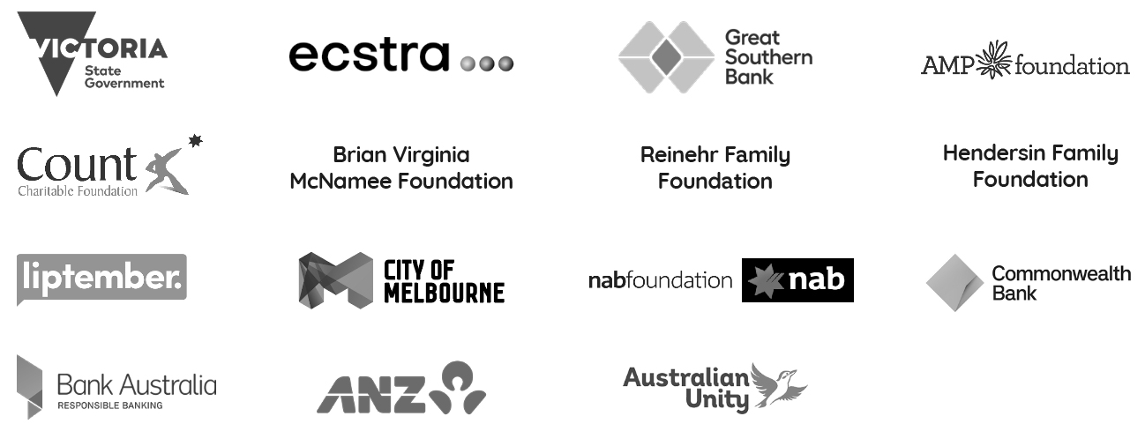

After another challenging year of adjusting to a COVID-world, the support we have received from our funders, partners, supporters, peers and friends has been more important than ever. We want to express our sincere thanks and appreciation. Your commitment to our work continues to have a significant positive impact on the lives of women and non-binary and gender diverse people in Victoria.
To our funders—the Victorian Government Department of Families Fairness and Housing, Victorian Department of Education and Training, and Victorian Department of Premier and Cabinet, Ecstra Foundation, Great Southern Bank, AMP Foundation, Count Charitable Foundation, Brian and Virginia McNamee Foundation, Reinehr Family Foundation, Henderson Family Foundation, Liptember Foundation, City of Melbourne, NAB Foundation, Commonwealth Bank, Bank Australia, ANZ, Australian Unity—thank you for investing in our projects, programs and service delivery. Your ongoing support makes it possible to continue our important work in the community.
To all of our donors, big, small and in-between, your support during this tumultuous time has been fundamental. Your care and generosity bolster our efforts to advocate for structural change, to bring about gender equity, family violence prevention and social justice.
To our project partners and supporters—First Nations Australia, Sisters4Sisters, Good Shepherd Australia New Zealand, Brotherhood of St Laurence, Women with Disabilities Victoria, Dr Nilmini Fernando, Yuimaru Partnerships, Navanita Bhattacharya, Nimo Hersi, Janet Curtain, Saki Saheli, Studio Kettle, Jill Faulkner, Radhika Santhanam-Martin, RPS Group, We are Lumen, FLP Financial, Warr Hunt, Urbis—thank you. The passion and expertise you bring to the table is insurmountable and we are honoured to work alongside you.
To all the organisations and job coaches who volunteer their time as part of our job coaching program; to everyone who participated in advisory and governance groups for our projects and programs; to all the individuals and lawyers who provided pro bono financial guidance and volunteered their time, including from Pearce Webster Dugdales, Farrell Family Lawyers, Sage Family Lawyers, Nicholes Family Lawyers, Farrar Gesini Dunn, Nest Legal, Mitchell Family Law, and TML Family Law; to Thirst Creative, Katie Ford Design, Pan Software, WESNET, PrintTogether and Minuteman Press - North Melbourne— thank you. And a big thank you to all the people who participated in our webinars and panel events, and everyone else who contributed to our research, programs and projects. We hope we can continue doing this wonderful work with you for years to come.
To our peers, the Victorian community sector organisations, and peak bodies and reference groups, GenVIC, DVVIC, Economic Abuse Reference Group, Financial Inclusion Action Plan (FIAP), Thriving Communities Partnership, Women’s Health Services—thank you for your ongoing passion, advocacy and for working alongside us to accomplish a more just and inclusive society where all people can thrive. And thank you to every other individual and organisation who has contributed and helped WIRE along the way to continue this important work with our community.

FINANCIALS
Click here to read WIRE’s 2020/21 audited financial reports.

I always feel very grateful to do this work and privileged that people trust me with their story. As part of the WIRE model, I listen deeply to the caller, reflecting back all the work they are already doing to advocate and care for themselves. Because when you’re deep in all these issues, it’s hard to see your own strengths. Sometimes just feeling heard and creating a safe space to speak is enough to make a caller feel empowered to take the next step in the journey.”
WIRE Support Worker

